OEQA FYT 2022 Report Teacher Prep program Only no written response
OEQA First Year Teacher Survey 2022
June 21st 2022, 10:50 am CDT
Q2 - Are you a first year teacher?
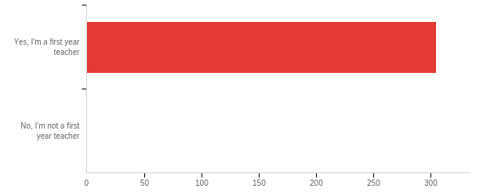

# | Field | Minimum | Maximum | Mean | Std Deviation | Variance | Count
1 | Are you a first year teacher? | 1.00 | 1.00 | 1.00 | 0.00 | 0.00 | 305

# | Answer | % | Count
1 | Yes, I'm a first year teacher | 100.00% | 305
2 | No, I'm not a first year teacher | 0.00% | 0
 | Total | 100% | 305

Q3 - Through which route did you receive your teaching license?
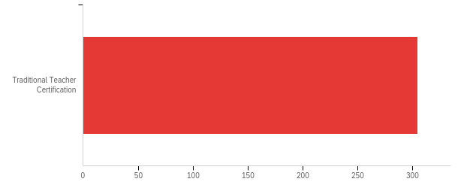

# | Field | Minimum | Maximum | Mean | Std Deviation | Variance | Count
1 | Through which route did you receive your teaching license? | 1.00 | 1.00 | 1.00 | 0.00 | 0.00 | 305

# | Answer | % | Count
1 | Traditional Teacher Certification | 100.00% | 305
 | Total | 100% | 305

Q4 - From which of the following institutions did you receive recommendation for teacher certification? If you hold an alternative or emergency certificate please select Oklahoma State Department of Education.
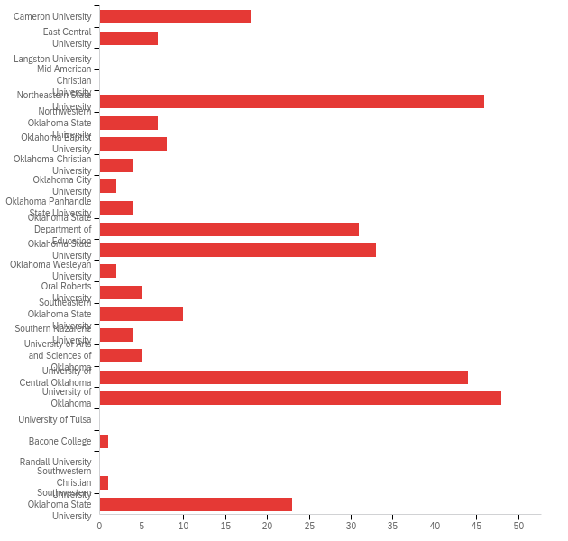

# | Field | Minimum | Maximum | Mean | Std Deviation | Variance | Count
1 | From which of the following institutions did you receive recommendation for teacher certification? If you hold an alternative or emergency certificate please select Oklahoma State Department of Education. | 1.00 | 26.00 | 13.81 | 6.90 | 47.61 | 303

# | Answer | % | Count
1 | Cameron University | 5.94% | 18
2 | East Central University | 2.31% | 7
3 | Langston University | 0.00% | 0
4 | Mid American Christian University | 0.00% | 0
6 | Northeastern State University | 15.18% | 46
7 | Northwestern Oklahoma State University | 2.31% | 7
8 | Oklahoma Baptist University | 2.64% | 8
9 | Oklahoma Christian University | 1.32% | 4
10 | Oklahoma City University | 0.66% | 2
11 | Oklahoma Panhandle State University | 1.32% | 4
12 | Oklahoma State Department of Education | 10.23% | 31
13 | Oklahoma State University | 10.89% | 33
14 | Oklahoma Wesleyan University | 0.66% | 2
15 | Oral Roberts University | 1.65% | 5
16 | Southeastern Oklahoma State University | 3.30% | 10
17 | Southern Nazarene University | 1.32% | 4
18 | University of Arts and Sciences of Oklahoma | 1.65% | 5
19 | University of Central Oklahoma | 14.52% | 44
20 | University of Oklahoma | 15.84% | 48
21 | University of Tulsa | 0.00% | 0
22 | Bacone College | 0.33% | 1
24 | Randall University | 0.00% | 0
25 | Southwestern Christian University | 0.33% | 1
26 | Southwestern Oklahoma State University | 7.59% | 23
 | Total | 100% | 303

Q6 - In what area did you receive your degree?
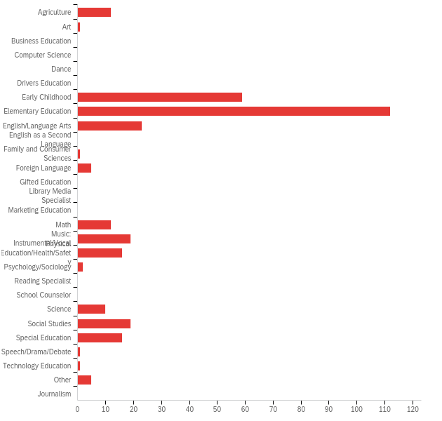

# | Answer | % | Count
1 | Agriculture | 3.82% | 12
2 | Art | 0.32% | 1
3 | Business Education | 0.00% | 0
4 | Computer Science | 0.00% | 0
5 | Dance | 0.00% | 0
6 | Drivers Education | 0.00% | 0
7 | Early Childhood | 18.79% | 59
8 | Elementary Education | 35.67% | 112
9 | English/Language Arts | 7.32% | 23
10 | English as a Second Language | 0.00% | 0
11 | Family and Consumer Sciences | 0.32% | 1
12 | Foreign Language | 1.59% | 5
13 | Gifted Education | 0.00% | 0
14 | Library Media Specialist | 0.00% | 0
15 | Marketing Education | 0.00% | 0
16 | Math | 3.82% | 12
17 | Music: Instrumental/Vocal | 6.05% | 19
18 | Physical Education/Health/Safety | 5.10% | 16
19 | Psychology/Sociology | 0.64% | 2
20 | Reading Specialist | 0.00% | 0
21 | School Counselor | 0.00% | 0
22 | Science | 3.18% | 10
23 | Social Studies | 6.05% | 19
24 | Special Education | 5.10% | 16
25 | Speech/Drama/Debate | 0.32% | 1
26 | Technology Education | 0.32% | 1
27 | Other | 1.59% | 5
28 | Journalism | 0.00% | 0
 | Total | 100% | 314

Q7 - In what year did you receive your degree?
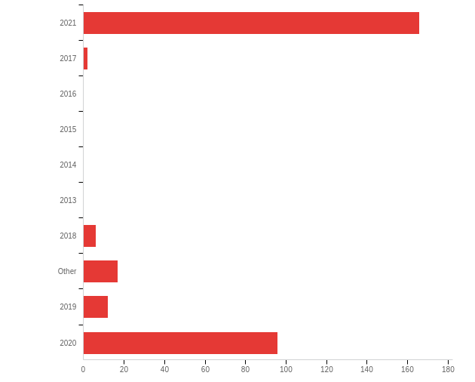

# | Field | Minimum | Maximum | Mean | Std Deviation | Variance | Count
1 | In what year did you receive your degree? - Selected Choice | 1.00 | 10.00 | 4.74 | 4.26 | 18.13 | 299

# | Answer | % | Count
1 | 2021 | 55.52% | 166
2 | 2017 | 0.67% | 2
3 | 2016 | 0.00% | 0
4 | 2015 | 0.00% | 0
5 | 2014 | 0.00% | 0
6 | 2013 | 0.00% | 0
7 | 2018 | 2.01% | 6
8 | Other | 5.69% | 17
9 | 2019 | 4.01% | 12
10 | 2020 | 32.11% | 96
 | Total | 100% | 299

Q8 - The Learner and Learning Please rate the extent to which you agree with each statement below. My preparation program/route to certification prepared me to:
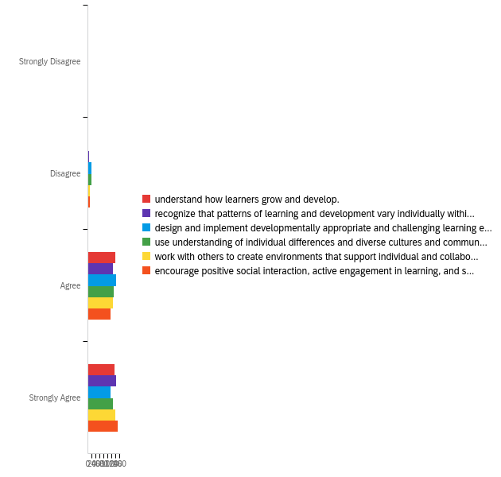

# | Field | Minimum | Maximum | Mean | Std Deviation | Variance | Count
1 | understand how learners grow and develop. | 1.00 | 4.00 | 3.47 | 0.53 | 0.29 | 275
2 | recognize that patterns of learning and development vary individually within and across the cognitive, linguistic, social, emotional, and physical areas. | 1.00 | 4.00 | 3.50 | 0.55 | 0.30 | 275
3 | design and implement developmentally appropriate and challenging learning experiences. | 1.00 | 4.00 | 3.33 | 0.63 | 0.40 | 275
4 | use understanding of individual differences and diverse cultures and communities to ensure inclusive learning environments that enable each learner to meet high standards. | 1.00 | 4.00 | 3.39 | 0.64 | 0.40 | 275
5 | work with others to create environments that support individual and collaborative learning. | 2.00 | 4.00 | 3.46 | 0.58 | 0.34 | 275
6 | encourage positive social interaction, active engagement in learning, and self-motivation. | 1.00 | 4.00 | 3.49 | 0.59 | 0.35 | 275

# | Question | Strongly Disagree |  | Disagree |  | Agree |  | Strongly Agree |  | Total
1 | understand how learners grow and develop. | 0.36% | 1 | 0.73% | 2 | 50.55% | 139 | 48.36% | 133 | 275
2 | recognize that patterns of learning and development vary individually within and across the cognitive, linguistic, social, emotional, and physical areas. | 0.36% | 1 | 1.45% | 4 | 46.18% | 127 | 52.00% | 143 | 275
3 | design and implement developmentally appropriate and challenging learning experiences. | 0.73% | 2 | 6.55% | 18 | 51.27% | 141 | 41.45% | 114 | 275
4 | use understanding of individual differences and diverse cultures and communities to ensure inclusive learning environments that enable each learner to meet high standards. | 0.73% | 2 | 6.18% | 17 | 46.91% | 129 | 46.18% | 127 | 275
5 | work with others to create environments that support individual and collaborative learning. | 0.00% | 0 | 4.36% | 12 | 45.45% | 125 | 50.18% | 138 | 275
6 | encourage positive social interaction, active engagement in learning, and self-motivation. | 0.36% | 1 | 4.00% | 11 | 41.45% | 114 | 54.18% | 149 | 275

Q9 - Content Please rate the extent to which you agree with each statement below. My preparation program/route to certification prepared me to:
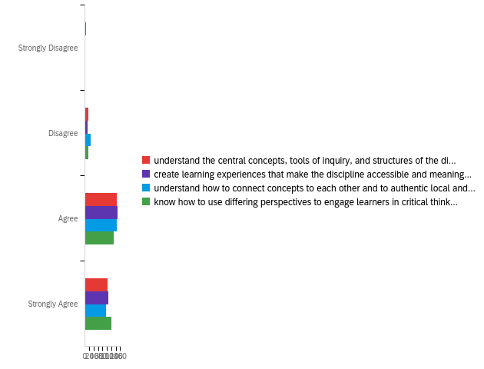

# | Field | Minimum | Maximum | Mean | Std Deviation | Variance | Count
1 | understand the central concepts, tools of inquiry, and structures of the discipline(s) I teach. | 1.00 | 4.00 | 3.29 | 0.65 | 0.42 | 268
2 | create learning experiences that make the discipline accessible and meaningful for learners to assure mastery of the content. | 1.00 | 4.00 | 3.35 | 0.58 | 0.34 | 268
3 | understand how to connect concepts to each other and to authentic local and global issues. | 2.00 | 4.00 | 3.25 | 0.63 | 0.39 | 268
4 | know how to use differing perspectives to engage learners in critical thinking, creativity, and collaborative problem solving. | 1.00 | 4.00 | 3.39 | 0.61 | 0.37 | 268

# | Question | Strongly Disagree |  | Disagree |  | Agree |  | Strongly Agree |  | Total
1 | understand the central concepts, tools of inquiry, and structures of the discipline(s) I teach. | 1.49% | 4 | 5.97% | 16 | 54.10% | 145 | 38.43% | 103 | 268
2 | create learning experiences that make the discipline accessible and meaningful for learners to assure mastery of the content. | 0.37% | 1 | 4.48% | 12 | 55.22% | 148 | 39.93% | 107 | 268
3 | understand how to connect concepts to each other and to authentic local and global issues. | 0.00% | 0 | 10.07% | 27 | 54.48% | 146 | 35.45% | 95 | 268
4 | know how to use differing perspectives to engage learners in critical thinking, creativity, and collaborative problem solving. | 0.37% | 1 | 5.60% | 15 | 48.88% | 131 | 45.15% | 121 | 268

Q10 - Instructional Practice Please rate the extent to which you agree with each statement below. My preparation program/route to certification prepared me to:
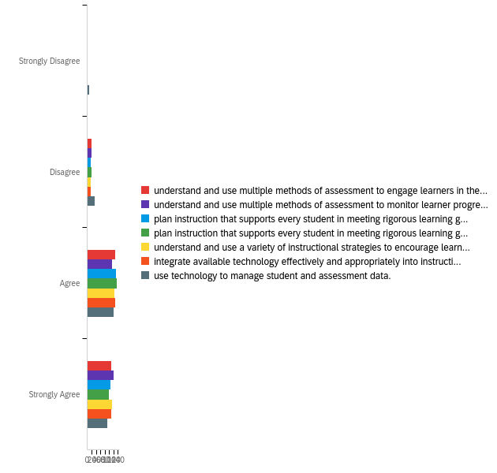

# | Field | Minimum | Maximum | Mean | Std Deviation | Variance | Count
1 | understand and use multiple methods of assessment to engage learners in their own growth and guide learners' decision making. | 2.00 | 4.00 | 3.35 | 0.62 | 0.38 | 254
2 | understand and use multiple methods of assessment to monitor learner progress and to guide my decision making. | 2.00 | 4.00 | 3.41 | 0.62 | 0.38 | 254
3 | plan instruction that supports every student in meeting rigorous learning goals by drawing upon knowledge of content areas, curriculum, cross-disciplinary skills, and pedagogy. | 1.00 | 4.00 | 3.33 | 0.63 | 0.40 | 254
4 | plan instruction that supports every student in meeting rigorous learning goals by drawing upon knowledge of learners and the community context. | 1.00 | 4.00 | 3.30 | 0.64 | 0.40 | 254
5 | understand and use a variety of instructional strategies to encourage learners to develop deep understanding of content areas and their connections, and to build skills to apply knowledge in meaningful ways. | 2.00 | 4.00 | 3.38 | 0.61 | 0.37 | 254
6 | integrate available technology effectively and appropriately into instruction. | 1.00 | 4.00 | 3.33 | 0.65 | 0.43 | 254
7 | use technology to manage student and assessment data. | 1.00 | 4.00 | 3.15 | 0.79 | 0.62 | 254

# | Question | Strongly Disagree |  | Disagree |  | Agree |  | Strongly Agree |  | Total
1 | understand and use multiple methods of assessment to engage learners in their own growth and guide learners' decision making. | 0.00% | 0 | 7.48% | 19 | 49.61% | 126 | 42.91% | 109 | 254
2 | understand and use multiple methods of assessment to monitor learner progress and to guide my decision making. | 0.00% | 0 | 7.09% | 18 | 44.88% | 114 | 48.03% | 122 | 254
3 | plan instruction that supports every student in meeting rigorous learning goals by drawing upon knowledge of content areas, curriculum, cross-disciplinary skills, and pedagogy. | 0.79% | 2 | 6.69% | 17 | 51.18% | 130 | 41.34% | 105 | 254
4 | plan instruction that supports every student in meeting rigorous learning goals by drawing upon knowledge of learners and the community context. | 0.79% | 2 | 7.48% | 19 | 53.15% | 135 | 38.58% | 98 | 254
5 | understand and use a variety of instructional strategies to encourage learners to develop deep understanding of content areas and their connections, and to build skills to apply knowledge in meaningful ways. | 0.00% | 0 | 6.69% | 17 | 48.43% | 123 | 44.88% | 114 | 254
6 | integrate available technology effectively and appropriately into instruction. | 1.18% | 3 | 6.69% | 17 | 49.61% | 126 | 42.52% | 108 | 254
7 | use technology to manage student and assessment data. | 3.94% | 10 | 12.99% | 33 | 47.24% | 120 | 35.83% | 91 | 254

Q11 - Professional Responsibility Please rate the extent to which you agree with each statement below. My preparation program/route to certification prepared me to:
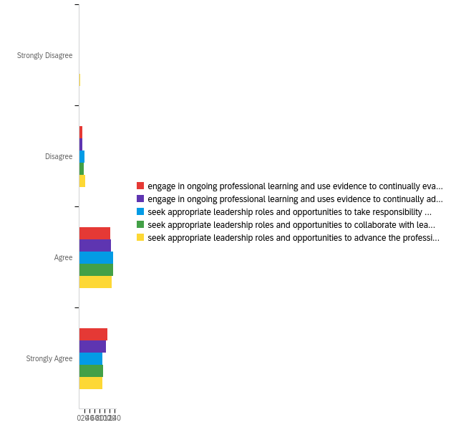

# | Field | Minimum | Maximum | Mean | Std Deviation | Variance | Count
1 | engage in ongoing professional learning and use evidence to continually evaluate my practice, particularly the effects of my choices and actions on others (learners, families, other professionals, and the community). | 1.00 | 4.00 | 3.39 | 0.60 | 0.36 | 248
2 | engage in ongoing professional learning and uses evidence to continually adapt practice to meet the needs of each learner. | 1.00 | 4.00 | 3.37 | 0.60 | 0.36 | 248
3 | seek appropriate leadership roles and opportunities to take responsibility for student learning. | 1.00 | 4.00 | 3.27 | 0.64 | 0.41 | 248
4 | seek appropriate leadership roles and opportunities to collaborate with learners, families, colleagues, other school professionals, and community members to ensure learner growth. | 1.00 | 4.00 | 3.29 | 0.63 | 0.39 | 248
5 | seek appropriate leadership roles and opportunities to advance the profession. | 1.00 | 4.00 | 3.25 | 0.68 | 0.46 | 248

# | Question | Strongly Disagree |  | Disagree |  | Agree |  | Strongly Agree |  | Total
1 | engage in ongoing professional learning and use evidence to continually evaluate my practice, particularly the effects of my choices and actions on others (learners, families, other professionals, and the community). | 0.40% | 1 | 4.84% | 12 | 50.00% | 124 | 44.76% | 111 | 248
2 | engage in ongoing professional learning and uses evidence to continually adapt practice to meet the needs of each learner. | 0.40% | 1 | 5.24% | 13 | 51.21% | 127 | 43.15% | 107 | 248
3 | seek appropriate leadership roles and opportunities to take responsibility for student learning. | 0.81% | 2 | 8.06% | 20 | 54.44% | 135 | 36.69% | 91 | 248
4 | seek appropriate leadership roles and opportunities to collaborate with learners, families, colleagues, other school professionals, and community members to ensure learner growth. | 0.81% | 2 | 6.85% | 17 | 54.44% | 135 | 37.90% | 94 | 248
5 | seek appropriate leadership roles and opportunities to advance the profession. | 1.21% | 3 | 9.68% | 24 | 51.61% | 128 | 37.50% | 93 | 248

Q12 - Overall, my preparation/route to certification effectively prepared me to have a positive impact on P12 student learning and development.
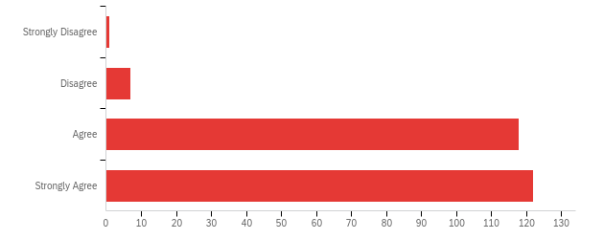

# | Field | Minimum | Maximum | Mean | Std Deviation | Variance | Count
1 | Overall, my preparation/route to certification effectively prepared me to have a positive impact on P12 student learning and development. | 1.00 | 4.00 | 3.46 | 0.57 | 0.33 | 248

# | Answer | % | Count
1 | Strongly Disagree | 0.40% | 1
2 | Disagree | 2.82% | 7
3 | Agree | 47.58% | 118
4 | Strongly Agree | 49.19% | 122
 | Total | 100% | 248

Q13 - What courses or experiences in your educator preparation/route to certification stand out as particularly important or meaningful?
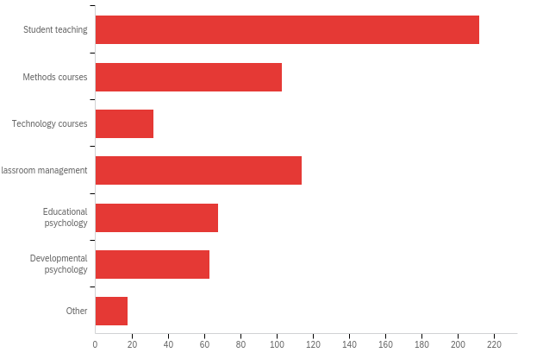

# | Answer | % | Count
10 | Student teaching | 34.75% | 212
11 | Methods courses | 16.89% | 103
12 | Technology courses | 5.25% | 32
13 | Classroom management | 18.69% | 114
14 | Educational psychology | 11.15% | 68
15 | Developmental psychology | 10.33% | 63
16 | Other | 2.95% | 18
 | Total | 100% | 610

Q14 - As you near the end of your first year of teaching, in what area(s) could you have used more preparation? (Please check all that apply)
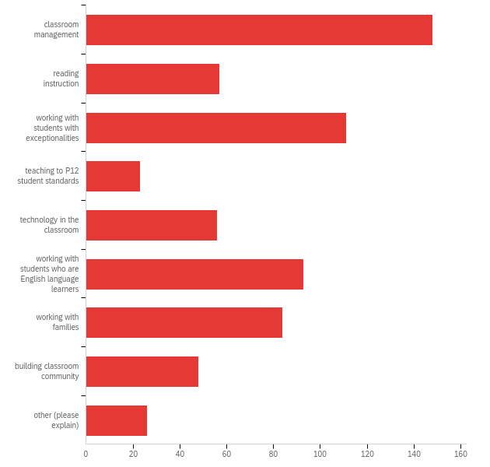

# | Answer | % | Count
1 | classroom management | 22.91% | 148
2 | reading instruction | 8.82% | 57
3 | working with students with exceptionalities | 17.18% | 111
4 | teaching to P12 student standards | 3.56% | 23
5 | technology in the classroom | 8.67% | 56
6 | working with students who are English language learners | 14.40% | 93
7 | working with families | 13.00% | 84
8 | building classroom community | 7.43% | 48
9 | other (please explain) | 4.02% | 26
 | Total | 100% | 646

Q16 - Were you assigned a mentor from your school district this school year?
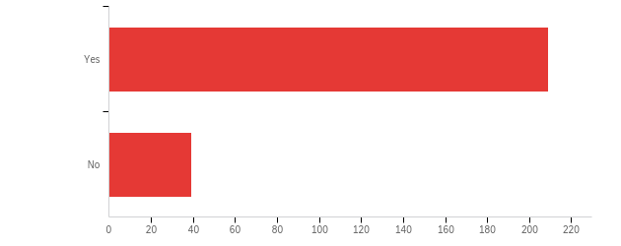

# | Field | Minimum | Maximum | Mean | Std Deviation | Variance | Count
1 | Were you assigned a mentor from your school district this school year? | 1.00 | 2.00 | 1.16 | 0.36 | 0.13 | 248

# | Answer | % | Count
1 | Yes | 84.27% | 209
2 | No | 15.73% | 39
 | Total | 100% | 248

Q17 - How much time did you spend with your mentor teacher?
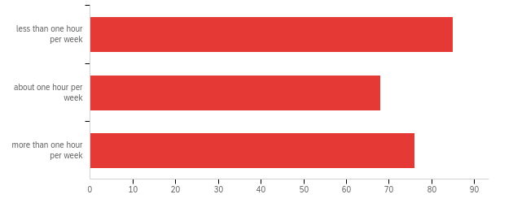

# | Field | Minimum | Maximum | Mean | Std Deviation | Variance | Count
1 | How much time did you spend with your mentor teacher? | 1.00 | 3.00 | 1.96 | 0.84 | 0.70 | 229

# | Answer | % | Count
1 | less than one hour per week | 37.12% | 85
2 | about one hour per week | 29.69% | 68
3 | more than one hour per week | 33.19% | 76
 | Total | 100% | 229

Q18 - Is your mentor in your same teaching area?
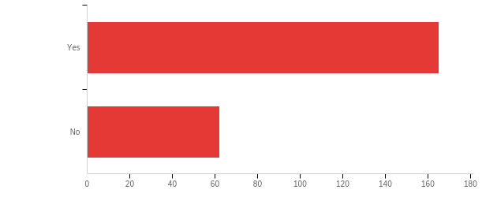

# | Field | Minimum | Maximum | Mean | Std Deviation | Variance | Count
1 | Is your mentor in your same teaching area? | 1.00 | 2.00 | 1.27 | 0.45 | 0.20 | 227

# | Answer | % | Count
1 | Yes | 72.69% | 165
2 | No | 27.31% | 62
 | Total | 100% | 227

Q19 - How satisfied are you with your mentoring experience?
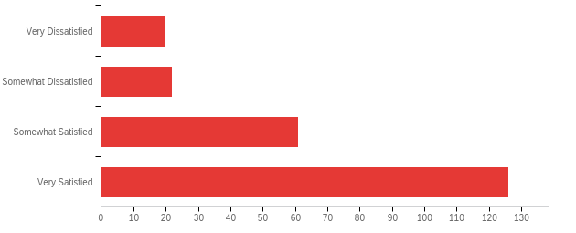

# | Field | Minimum | Maximum | Mean | Std Deviation | Variance | Count
1 | How satisfied are you with your mentoring experience? | 1.00 | 4.00 | 3.28 | 0.96 | 0.92 | 229

# | Answer | % | Count
1 | Very Dissatisfied | 8.73% | 20
2 | Somewhat Dissatisfied | 9.61% | 22
3 | Somewhat Satisfied | 26.64% | 61
4 | Very Satisfied | 55.02% | 126
 | Total | 100% | 229

Q20 - How might the mentoring experience be improved?
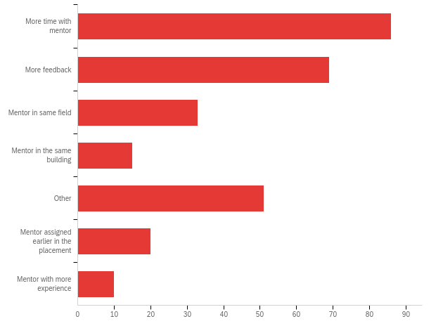

# | Answer | % | Count
1 | More time with mentor | 30.28% | 86
2 | More feedback | 24.30% | 69
3 | Mentor in same field | 11.62% | 33
4 | Mentor in the same building | 5.28% | 15
5 | Other | 17.96% | 51
6 | Mentor assigned earlier in the placement | 7.04% | 20
7 | Mentor with more experience | 3.52% | 10
 | Total | 100% | 284

Q10 - In what area(s) were you initially certified? (Please check all that apply)
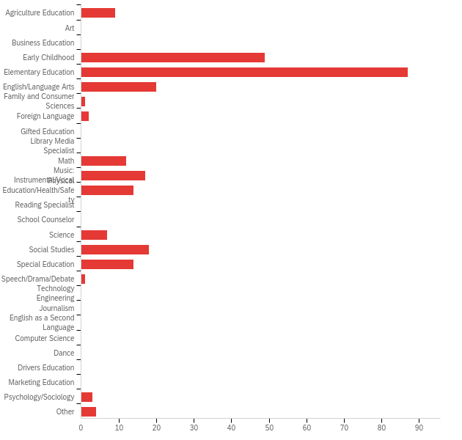

# | Answer | % | Count
1 | Agriculture Education | 3.49% | 9
2 | Art | 0.00% | 0
3 | Business Education | 0.00% | 0
4 | Early Childhood | 18.99% | 49
5 | Elementary Education | 33.72% | 87
6 | English/Language Arts | 7.75% | 20
7 | Family and Consumer Sciences | 0.39% | 1
8 | Foreign Language | 0.78% | 2
9 | Gifted Education | 0.00% | 0
10 | Library Media Specialist | 0.00% | 0
11 | Math | 4.65% | 12
12 | Music: Instrumental/Vocal | 6.59% | 17
13 | Physical Education/Health/Safety | 5.43% | 14
14 | Reading Specialist | 0.00% | 0
15 | School Counselor | 0.00% | 0
16 | Science | 2.71% | 7
17 | Social Studies | 6.98% | 18
18 | Special Education | 5.43% | 14
19 | Speech/Drama/Debate | 0.39% | 1
20 | Technology Engineering | 0.00% | 0
21 | Journalism | 0.00% | 0
22 | English as a Second Language | 0.00% | 0
23 | Computer Science | 0.00% | 0
24 | Dance | 0.00% | 0
25 | Drivers Education | 0.00% | 0
26 | Marketing Education | 0.00% | 0
27 | Psychology/Sociology | 1.16% | 3
35 | Other | 1.55% | 4
 | Total | 100% | 258

Q22 - What is your current primary teaching assignment? (Please check all that apply)
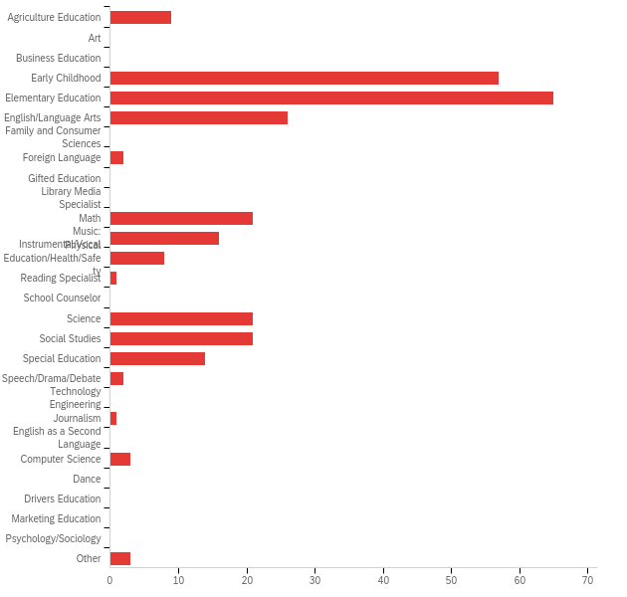

# | Answer | % | Count
1 | Agriculture Education | 3.33% | 9
2 | Art | 0.00% | 0
3 | Business Education | 0.00% | 0
4 | Early Childhood | 21.11% | 57
5 | Elementary Education | 24.07% | 65
6 | English/Language Arts | 9.63% | 26
7 | Family and Consumer Sciences | 0.00% | 0
8 | Foreign Language | 0.74% | 2
9 | Gifted Education | 0.00% | 0
10 | Library Media Specialist | 0.00% | 0
11 | Math | 7.78% | 21
12 | Music: Instrumental/Vocal | 5.93% | 16
13 | Physical Education/Health/Safety | 2.96% | 8
14 | Reading Specialist | 0.37% | 1
15 | School Counselor | 0.00% | 0
16 | Science | 7.78% | 21
17 | Social Studies | 7.78% | 21
18 | Special Education | 5.19% | 14
19 | Speech/Drama/Debate | 0.74% | 2
20 | Technology Engineering | 0.00% | 0
21 | Journalism | 0.37% | 1
22 | English as a Second Language | 0.00% | 0
23 | Computer Science | 1.11% | 3
24 | Dance | 0.00% | 0
25 | Drivers Education | 0.00% | 0
26 | Marketing Education | 0.00% | 0
27 | Psychology/Sociology | 0.00% | 0
35 | Other | 1.11% | 3
 | Total | 100% | 270

Q23 - In what additional area(s) are you certified? (Please check all that apply)
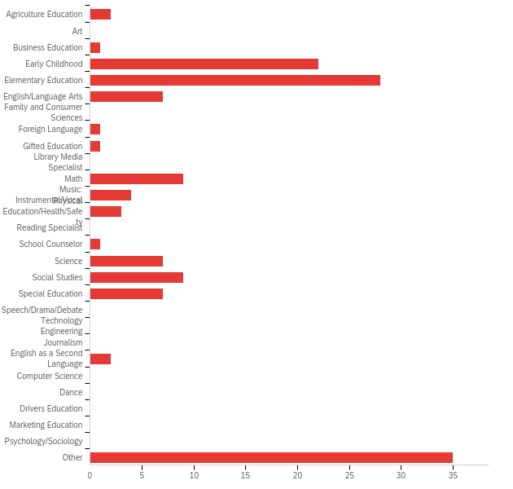

# | Answer | % | Count
1 | Agriculture Education | 1.44% | 2
2 | Art | 0.00% | 0
3 | Business Education | 0.72% | 1
4 | Early Childhood | 15.83% | 22
5 | Elementary Education | 20.14% | 28
6 | English/Language Arts | 5.04% | 7
7 | Family and Consumer Sciences | 0.00% | 0
8 | Foreign Language | 0.72% | 1
9 | Gifted Education | 0.72% | 1
10 | Library Media Specialist | 0.00% | 0
11 | Math | 6.47% | 9
12 | Music: Instrumental/Vocal | 2.88% | 4
13 | Physical Education/Health/Safety | 2.16% | 3
14 | Reading Specialist | 0.00% | 0
15 | School Counselor | 0.72% | 1
16 | Science | 5.04% | 7
17 | Social Studies | 6.47% | 9
18 | Special Education | 5.04% | 7
19 | Speech/Drama/Debate | 0.00% | 0
20 | Technology Engineering | 0.00% | 0
21 | Journalism | 0.00% | 0
22 | English as a Second Language | 1.44% | 2
23 | Computer Science | 0.00% | 0
24 | Dance | 0.00% | 0
25 | Drivers Education | 0.00% | 0
26 | Marketing Education | 0.00% | 0
27 | Psychology/Sociology | 0.00% | 0
35 | Other | 25.18% | 35
 | Total | 100% | 139

Q24 - What other roles do you fill at your school? (Please check all that apply)
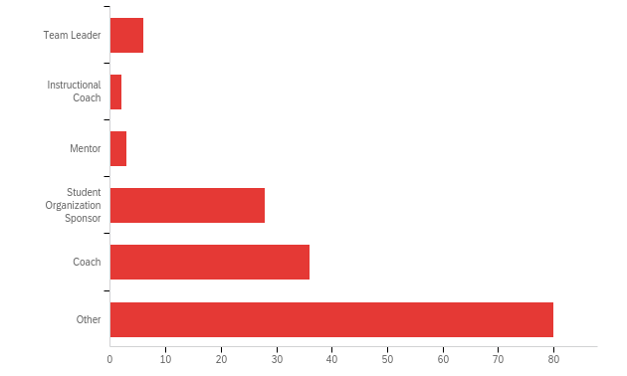

# | Answer | % | Count
1 | Team Leader | 3.87% | 6
2 | Instructional Coach | 1.29% | 2
3 | Mentor | 1.94% | 3
4 | Student Organization Sponsor | 18.06% | 28
5 | Coach | 23.23% | 36
6 | Other | 51.61% | 80
 | Total | 100% | 155

Q25 - Do you teach at a Title I school?
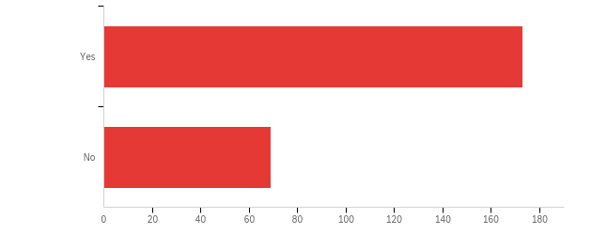

# | Field | Minimum | Maximum | Mean | Std Deviation | Variance | Count
1 | Do you teach at a Title I school? | 1.00 | 2.00 | 1.29 | 0.45 | 0.20 | 242

# | Answer | % | Count
1 | Yes | 71.49% | 173
2 | No | 28.51% | 69
 | Total | 100% | 242

Q26 - Which of the following describes your school district?
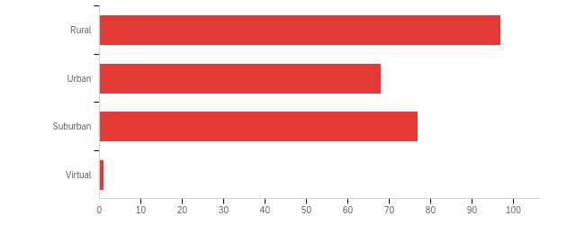

# | Field | Minimum | Maximum | Mean | Std Deviation | Variance | Count
1 | Which of the following describes your school district? | 1.00 | 4.00 | 1.93 | 0.85 | 0.73 | 243

# | Answer | % | Count
1 | Rural | 39.92% | 97
2 | Urban | 27.98% | 68
3 | Suburban | 31.69% | 77
4 | Virtual | 0.41% | 1
 | Total | 100% | 243

Q27 - As a high school student, did you participate in any programs or classes that influenced your decision to become a teacher?
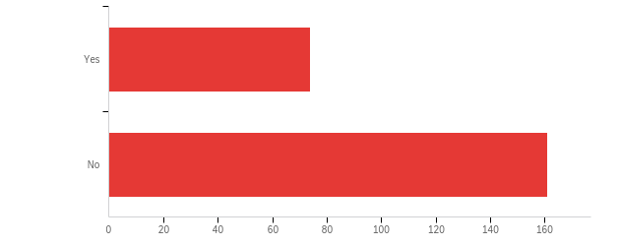

# | Field | Minimum | Maximum | Mean | Std Deviation | Variance | Count
1 | As a high school student, did you participate in any programs or classes that influenced your decision to become a teacher? | 1.00 | 2.00 | 1.69 | 0.46 | 0.22 | 235

# | Answer | % | Count
1 | Yes | 31.49% | 74
2 | No | 68.51% | 161
 | Total | 100% | 235

